1. There are two main components of this “**Fork Join Framework**”.
   1. ForkJoinPool
   2. ForkJoinTask
2. **ForkJoinPool** is kind of executor server for FormJoinTask.
3. 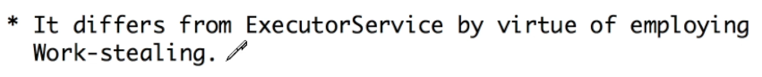
   1. If a worker thread has no task in pipeline, it will take the task from the task queue of other busy thread so that the workload is efficiently balanced & this is referred to as “**Work-stealing**”.